Index:

1. Visualizing
2. Error Values
3. Plot
4. Conclusion
5. Visualizing

For Adelie and Gentoo

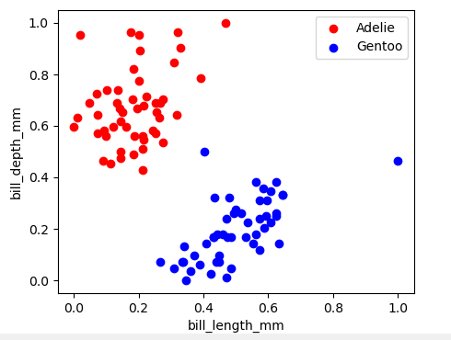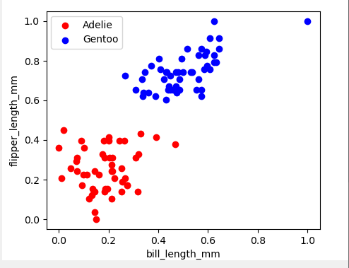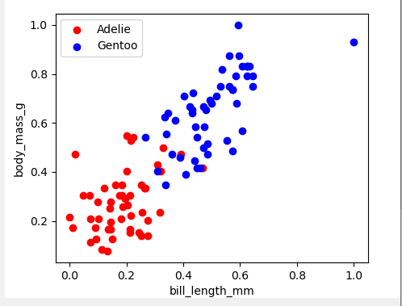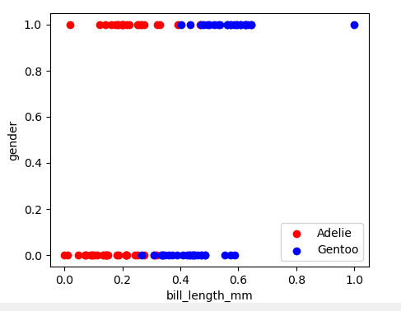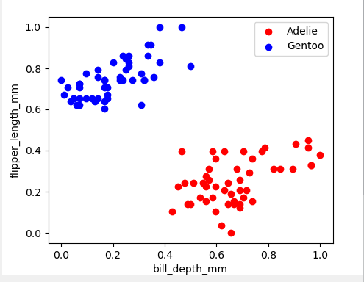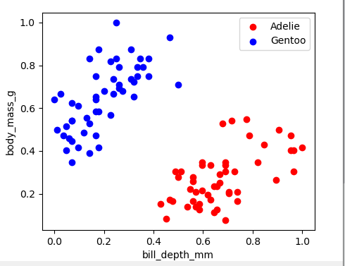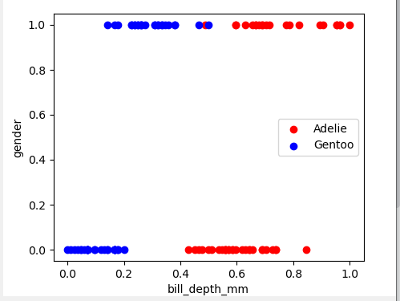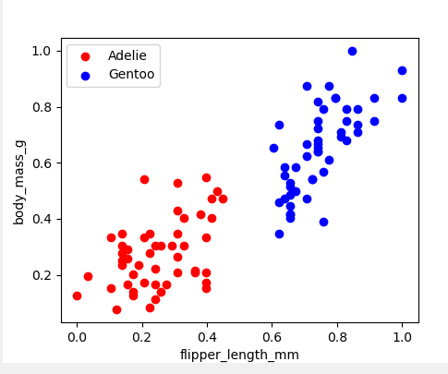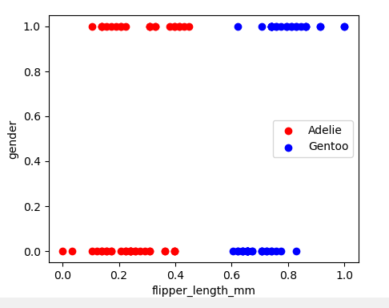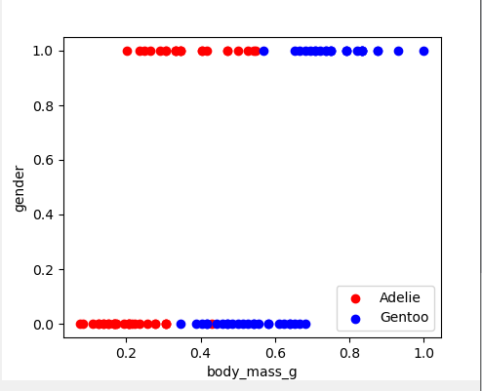

For Adelie and Chinstrap

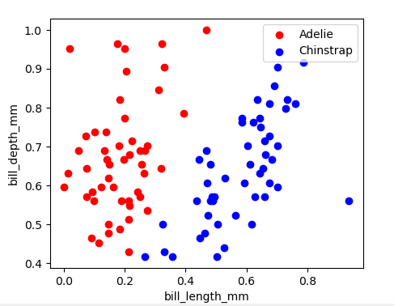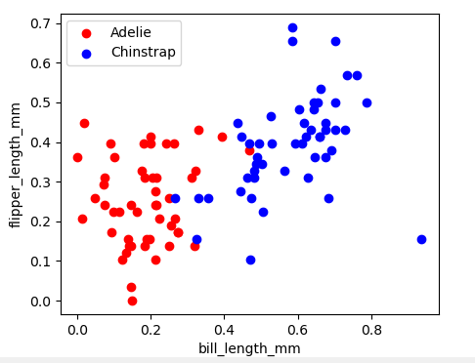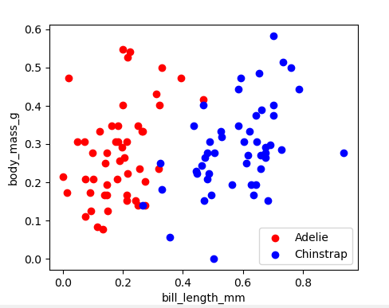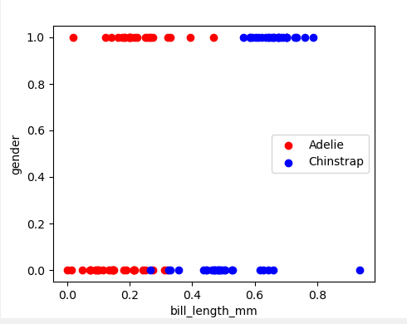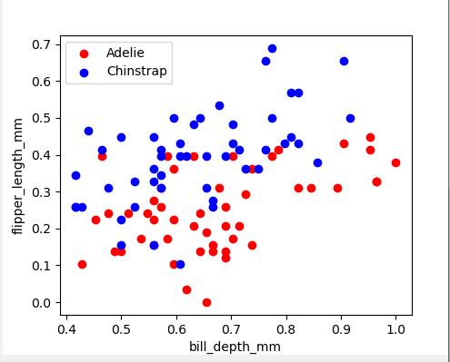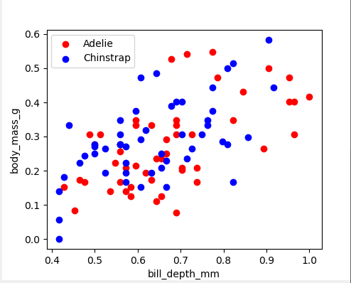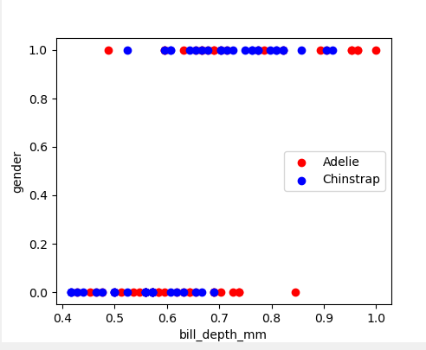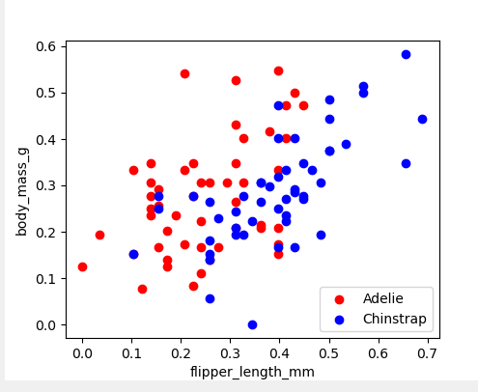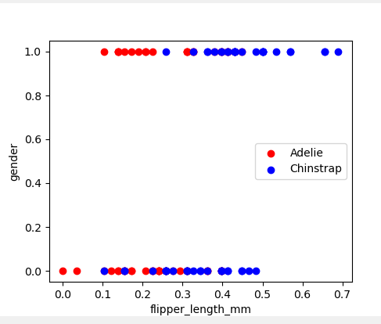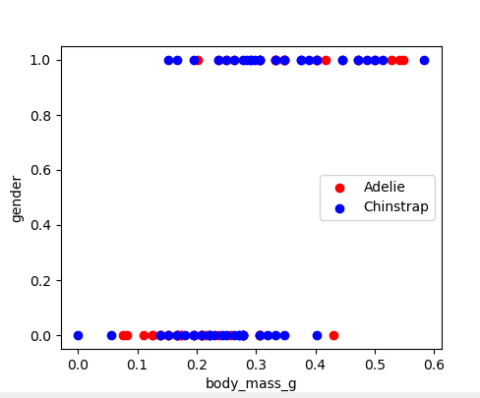

For Gentoo and Chinstrap

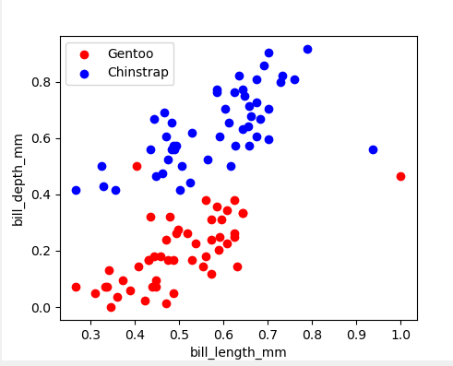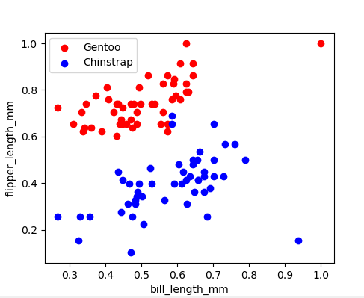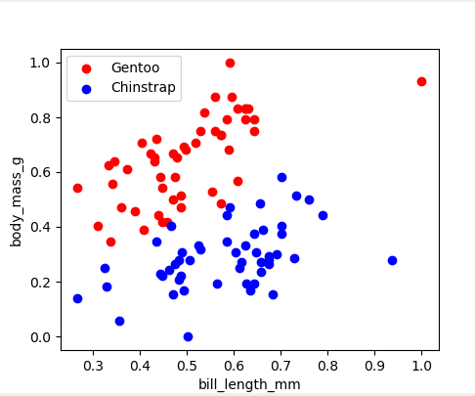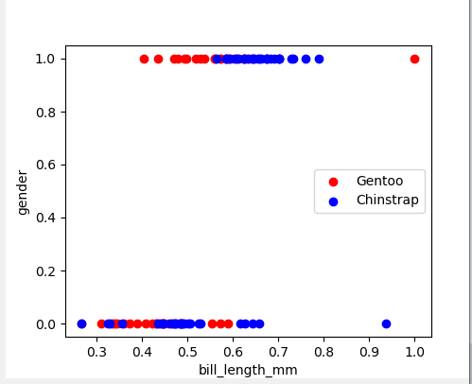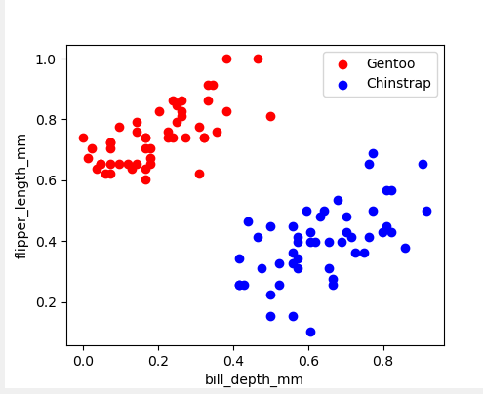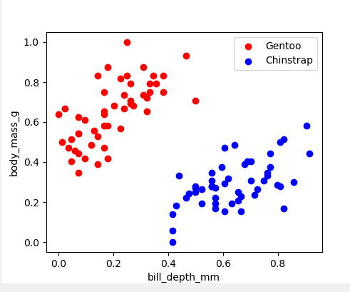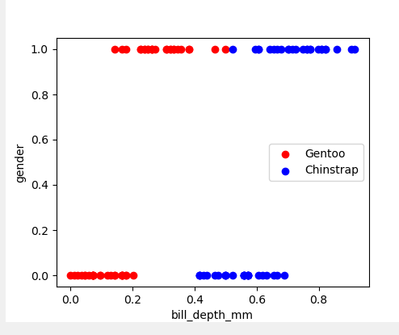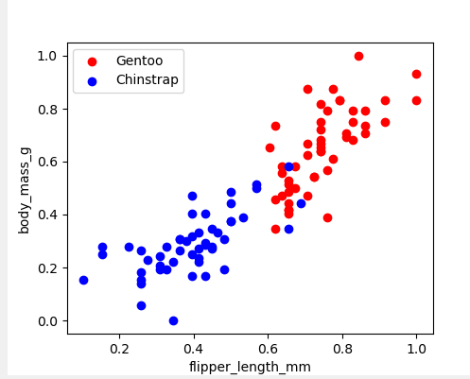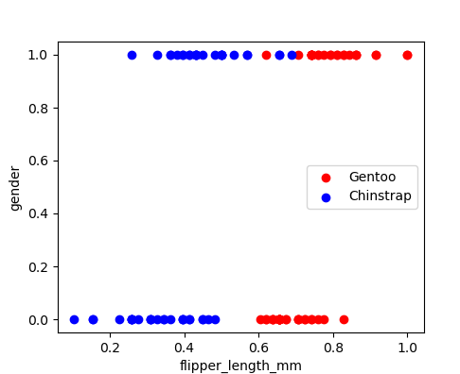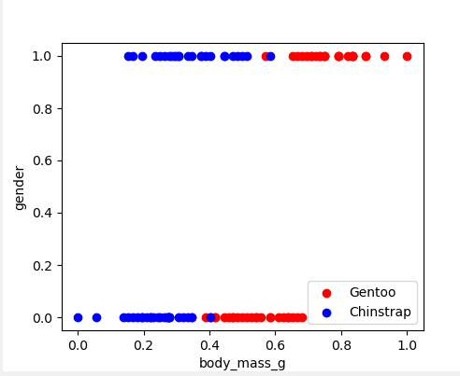

1. Error Values

Bias = not

Learn rate = 0.01

Epochs = 1000

* Adelie and Chinstrap

| Bill length and bill depth | 0.03 |
| --- | --- |
| Bill length and flipper length | 0.083 |
| Bill length and body mass | 0.016 |
| Bill length and gender | 0.025 |
| bill depth and flipper length | 0.1 |
| bill depth and body mass | 0.283 |
| bill depth and gender | 0.03 |
| flipper length and body mass | 0.15 |
| flipper length and gender | 0.3 |
| body mass and gender | 0.025 |

* Adelie and Gentoo

| Bill length and bill depth | 0 |
| --- | --- |
| Bill length and flipper length | 0.3 |
| Bill length and body mass | 0.26 |
| Bill length and gender | 0.016 |
| bill depth and flipper length | 0 |
| bill depth and body mass | 0 |
| bill depth and gender | 0.3 |
| flipper length and body mass | 0.25 |
| flipper length and gender | 0.008 |
| body mass and gender | 0 |

* Chinstrap and Gentoo

| Bill length and bill depth | 0 |
| --- | --- |
| Bill length and flipper length | 0 |
| Bill length and body mass | 0 |
| Bill length and gender | 0 |
| bill depth and flipper length | 0 |
| bill depth and body mass | 0 |
| bill depth and gender | 0 |
| flipper length and body mass | 0 |
| flipper length and gender | 0 |
| body mass and gender | 0.0083 |

1. Plot

Bias = not

Learn rate = 0.01

Epochs = 1000

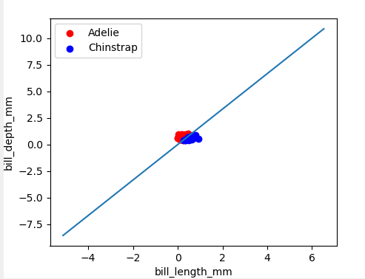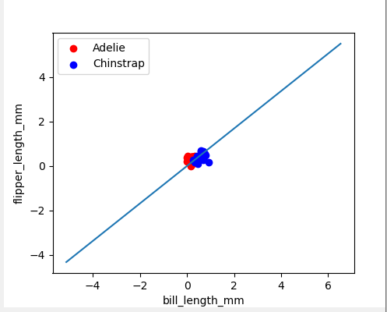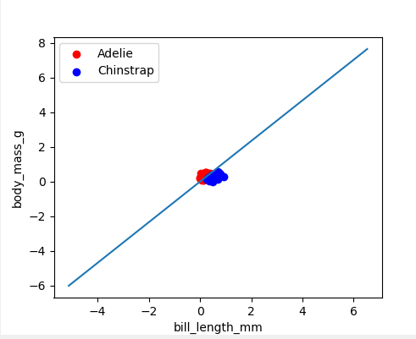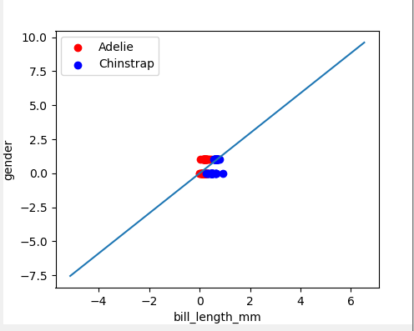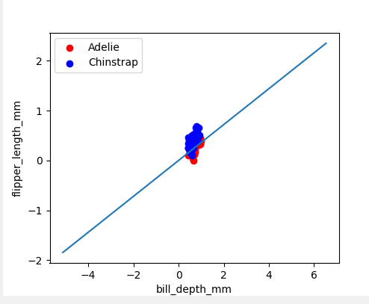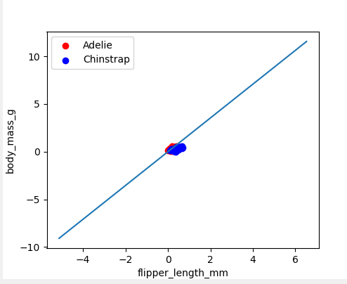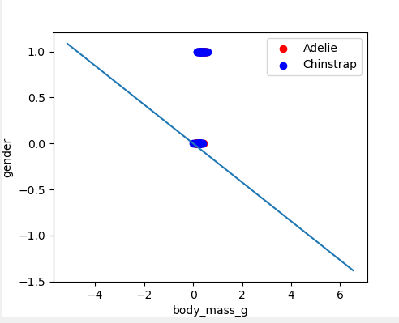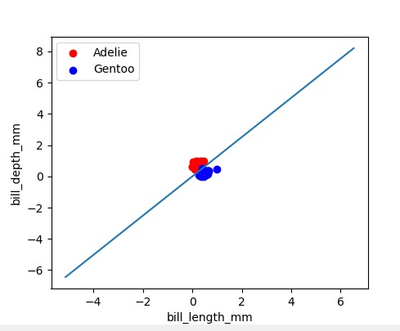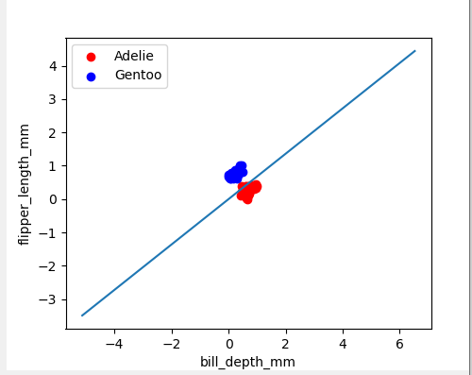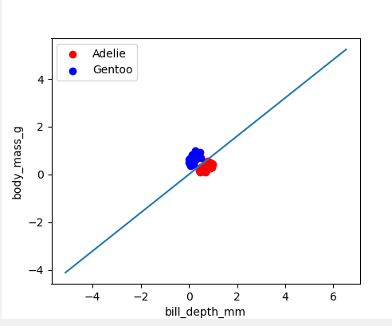

1. Conclusion

Best Features are :

| Bill length and bill depth |
| --- |